**Kol Simcha Torah Gazette**

**For parsha vayigash 5785**

Volume 9 Issue 15 (Whole #429) 4 Tevet 5785/ January 4, 2025

**Printed L’illuy nishmas Nechama bas R’ Noach, a”h**

For a free subscription, please forward your request to [***keren18@juno.com***](mailto:keren18@juno.com)

***Past emails can be found on the website ShabbosStories.com under Brooklyn Torah Gazette***

**Jimmy Carter, 100, Died on 4th Light of Chanukah, 45 Years to the Day Since Inaugurating the National Menorah**

**By** [**Dovid Margolin, Yaakov Ort and Mendel Super**](https://www.chabad.org/search/keyword_cdo/kid/15680/jewish/Margolin-Dovid.htm)

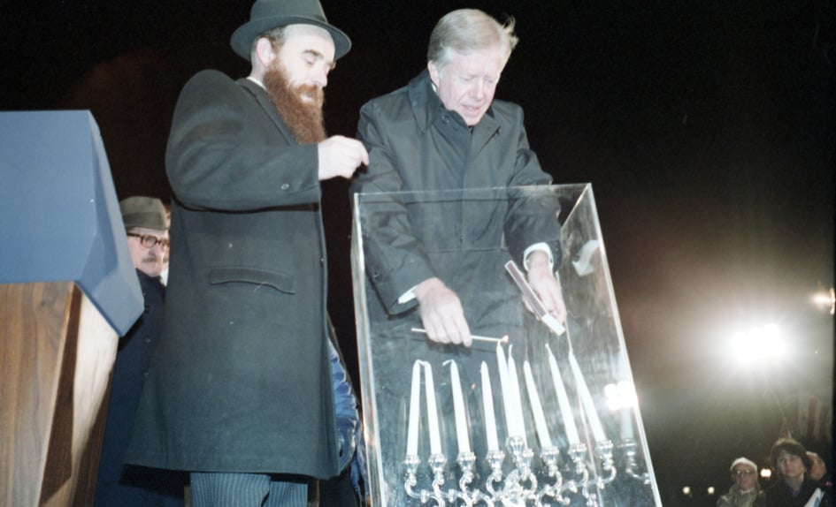

***On the fourth night of Chanukah, 1979, Jimmy Carter became the first American president in history to publicly light a Chanukah menorah, kicking off an annual tradition in Washington, D.C. Photo: Jimmy Carter Presidential Library and Museum***

In late 1979 the Embassy of the United States in Tehran was overrun by Iranian student terrorists and [50 Americans taken hostage](https://www.chabad.org/therebbe/article_cdo/aid/2608163/jewish/The-Israeli-Journalist-Iran-and-the-Rebbes-Vision.htm). The embassy attack was a brazen affront to U.S. prestige worldwide, and [President Jimmy Carter](https://www.chabad.org/search/keyword_cdo/kid/14734) came under unrelenting pressure to secure the safe return of the hostages. In the midst of the ever-worsening Iran Hostage Crisis, the beleaguered president stepped out of the White House one mid-December evening to dedicate the first-ever lighting of the [National Chanukah Menorah](https://www.chabad.org/therebbe/letters/default_cdo/aid/2232615/jewish/Participation-of-President-Jimmy-Carter-at-the-National-Menorah-Lighting.htm).

It was the fourth night of Chanukah, Dec. 17, 1979. With advisor Stuart Eizenstat and administration staff at his side, the president left the White House on foot, crossing the street to enter Lafayette Park, where the giant menorah had been erected. There he was greeted by Chabad-Lubavitch Rabbi Abraham Shemtov, who escorted him to the podium. Carter was honored with the lighting of the [*shamash*](https://www.chabad.org/holidays/chanukah/article_cdo/aid/3887323/jewish/The-Shamash-Why-the-Menorah-Has-a-9th-Candle.htm)—the candle from which the others are kindled—after which Eizenstat, his two young sons, and incoming Secretary of Commerce Philip Klutznick lit the candles on the [menorah](https://www.chabad.org/library/article_cdo/aid/609661/jewish/The-Menorah.htm). After a few words by Shemtov, the rabbi introduced the president to share his thoughts with the assembled crowd.

“[T]he season of [Chanukah](https://www.chabad.org/holidays/chanukah/default_cdo/jewish/Chanukah-Hanukkah-2024-2025.htm) commemorates the victory of religious freedom,” President Carter [said](https://www.presidency.ucsb.edu/documents/chanukah-remarks-the-lighting-the-national-menorah) as he stood next to the [menorah](https://www.chabad.org/multimedia/video_cdo/aid/2271401/jewish/The-Design-of-the-Temple-Menorah.htm). “At the commencement of the celebration of this annual event, this season of thanksgiving and closeness to G‑d, there was a miracle within which the candle which was supposed to only burn a short time burned for eight days and nights.”

With the 52 American hostages on his mind, Carter saw more than just a history lesson in the message of Chanukah. “This miracle,” he said, “showed that [G‑d](https://www.chabad.org/library/article_cdo/aid/433240/jewish/God.htm) meets our needs. If we depend on Him, He will meet our needs.”

The White House had prepared short remarks for the president, but he chose to discard them and speak extemporaneously from the heart.

“This season commemorates the perpetuation of age-old dreams and the hunger of men and women down through the ages to maintain a spirit committed to life under the most difficult circumstances, the most difficult persecutions, the most difficult dangers, and the most difficult suffering,” Carter continued. “It also commemorates humankind’s commitment to be free. These commitments to live and to be free are ever present these days in the minds and hearts of all Americans, because we know that 50 of our fellow human beings, our fellow citizens, are not free and they want to live. We pray that this will prevail, this desire to be free and to maintain life.”

Echoing a [Chassidic teaching](https://www.chabad.org/library/article_cdo/aid/4955054/jewish/Sharing-Light.htm), the president noted that the *shamash*candle’s light does not diminish when it shares its flame with others. “It shows that when we give life and love to others, the life and love in our own hearts is not diminished. As a matter of fact, it grows the more we share it. So, tonight we pray that our closeness to G‑d, our memory of these fine commitments of human beings down through the ages will strengthen our desires to share our life and our love … for men and women throughout the world who don't always have freedom and whose lives might be in danger.”

That fourth light of Chanukah, Jimmy Carter, who died at age 100 on Dec. 29, 2024, became the first American president in history to publicly light a [Chanukah](https://www.chabad.org/chanukah) menorah, kicking off an annual Washington, D.C., tradition that has helped launch the Jewish holiday into the public sphere. Chanukah is celebrated according to the Jewish calendar, and Carter’s passing occurred on the fourth light of the holiday—exactly 45 years to the day since he kindled the [menorah](https://www.chabad.org/library/article_cdo/aid/609661/jewish/The-Menorah.htm).

The National Menorah was the brainchild of Shemtov, a Chabad emissary in Philadelphia who also chairs American Friends of Lubavitch ([Chabad](https://www.chabad.org/library/article_cdo/aid/244369/jewish/About-Chabad-Lubavitch.htm)) in Washington, D.C, serving for more than half a century as [representative](https://www.chabad.org/therebbe/article_cdo/aid/938489/jewish/A-Rabbis-Capitol-Hill-Missions.htm) of [the Rebbe, Rabbi Menachem M. Schneerson](http://therebbe.org/), of righteous memory, to the nation’s capital. Just a few years earlier, in the winter of 1973, the Rebbe launched a [Chanukah awareness campaign](https://www.chabad.org/news/article_cdo/aid/6211511/jewish/Fifty-Years-of-Illuminating-the-World-Chanukah-Campaign-Hits-Milestone.htm), urging increased private observations and public displays of the eight-day holiday.

When he initiated the Chanukah campaign, the Rebbe spoke of the need to bring the light of the menorah to the streets, not only as a reminder that Jews in America are free of persecution and deserve to enjoy their rights as a minority, but as a universal message of freedom and liberty for all. On Chanukah 1974—exactly 50 years ago—Shemtov erected the [first-ever public menorah](https://www.chabad.org/news/article_cdo/aid/6721099/jewish/Born-in-Philly-the-Public-Menorah-Turns-50.htm) in Independence Mall in Philadelphia, followed quickly by giant Chabad menorahs in San Francisco and New York City. The National Menorah was perhaps the most prominent of them all.

“I … take this opportunity of expressing to you my genuine gratification at your personal participation in the ceremony of lighting the Chanukah Candelabra in front of the White House,” the [Rebbe wrote to Carter](https://www.chabad.org/therebbe/letters/default_cdo/aid/2232615/jewish/Participation-of-President-Jimmy-Carter-at-the-National-Menorah-Lighting.htm) several weeks after his dedication of the National Menorah. “The symbol of light is universal for all people on earth, Jews and non-Jews. The intrinsic power of light, in that even a small light dispels a lot of darkness, is surely a source of inspiration to all men of good will with its eternal message of the eventual triumph of all that is good and bright in human life.”

Eizenstat, the president’s domestic affairs chief, had played a key role in setting up the National Menorah, and the Rebbe [wrote separately](https://www.chabad.org/therebbe/article_cdo/aid/816546/jewish/The-Start-of-Education-Day-USA.htm) thanking him, noting in particular the participation of Eizenstat’s wife and young sons—who recited the blessings on the menorah—in the ceremony. (The renowned opera tenor [Jan Peerce](https://www.chabad.org/therebbe/letters/default_cdo/aid/2083496/jewish/The-Gift-of-Music-A-Letter-to-Jan-Peerce.htm) sang [*Maoz Tzur*](https://www.chabad.org/multimedia/music_cdo/aid/104615/jewish/Maoz-Tzur.htm).)

But it was the president himself, Carter, who inaugurated the new national tradition.

“I felt it was important for our country to practice its commitment to religious pluralism by lighting the menorah on U.S. Park Service land,” Carter told the [*Washington Post*](https://www.washingtonpost.com/history/2020/12/10/jimmy-carter-hanukkah-menorah-white-house/) in 2020. “I hoped this would help elevate this Jewish holiday into one all Americans would recognize, and I am grateful this annual event has grown much larger over time.”

Indeed, every administration has participated in the National Menorah celebration since, and the annual event—which moved from Lafayette Park to the Ellipse in 1987—draws thousands of participants, and the menorah is seen by millions. Today, the Chabad movement erects some 15,000 giant public menorahs around the world.

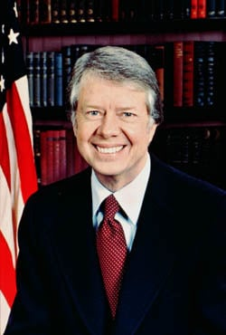

**President Jimmy Carter**

**Conflicting Legacy**

President James Earl (“Jimmy”) Carter was born on Oct. 1, 1924, in Plains, Georgia, where he lived for most of his life. A Navy veteran and activist in the civil-rights movement, he began his political career in 1963 as a Georgia state senator before being elected governor of Georgia in 1970. In 1976, he defeated incumbent President Gerald Ford and served one term as president until his defeat by Ronald Reagan in the 1980 election.

Carter’s legacy is not a simple one. His position towards Israel during his presidency severely hampered its ability to defend itself, and his post-presidential Middle East activism led many to question Carter’s affinity for the Jewish people in the first place. Nevertheless, as the Rebbe highlighted in particular in the aftermath of, and in reference to, Carter’s 1980 loss, “Torah bids us to be grateful [and] to acknowledge those *good things* which were done.”

*Reprinted from the current website of Chabad.Org*

**Rav Avigdor Miller on**

**Blame the Jews**

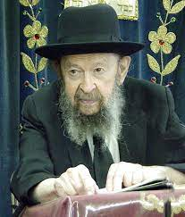

**QUESTION:** I’m wondering about who the real reshaim (evil people) were in the story of Chanukah. Sometimes we seem to blame it on the Misyavnim, the Jewish Hellenizers, but then it seems like it was really Antiochus and the Greeks who caused all the trouble, like we say in Al Hanissim

**ANSWER:** You have to know that in the siddur when you read that “the kingdom of the Greeks arose against the Jewish people”, it’s not the whole truth. Because the truth is that the whole calamity was caused by Jews, by renegade Jews who wanted to adopt the ways of the Greeks. Only that these Jews used the Greeks as a way of forcing their fellow Jews to forsake the Torah.

Only that the Sages who established this prayer always tried to protect the honor of the Jewish people. They didn't want the truth to be known and so they blamed the Greeks, the ones who actually did the work of the renegade Jews, and they left out the cause, the ones who caused the Greeks to come against the nation.

And at the end of the whole thing, finally Antiochus, after many wars, he became so disgusted that he said: "What do they want of me? Why are the Jews dragging me into their own personal problems? The Jews want to keep their religion, what business is it of mine?"

And at the end he gave up, just before he died. He gave up the whole business because he wasn't interested in the whole thing. Only that he was being prodded and pushed constantly by these Hellenizer Jews.

It's only from people like me who like to rake up mud and tell the dirt that you’ll hear this. And I wouldn't tell it either, but since it's already told – Josephus tells the whole story and the Book of Maccabees tells the whole story anyhow – so now it's no secret anymore. It was Jews who caused the whole thing.

*Reprinted from the Parshas Vayigash 5785 email of Toras Avigdor, - (December 1970)*

**The Importance of Being**

**Severe Sparingly**

**From the Teachings of the Lubavitcher Rebbe**

**Rabbi Menachem Mendel Schneerson, Zt”l**

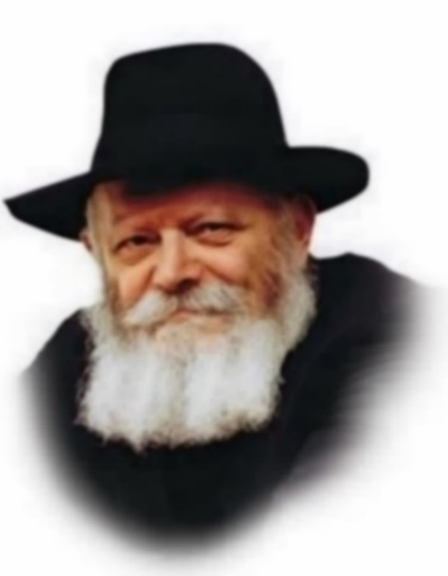

In the Torah portion of Vayigash, Joseph finally reveals his identity to his brothers. "I am Joseph," he says, "is my father still alive?"

The question itself demands further explanation. Judah had just told Joseph that Jacob was unwilling to send Benjamin down to Egypt, fearing that he would die there. He had also just stated that if Benjamin were to be detained in Egypt, he was afraid that his father might not survive. It is obvious that Joseph knew that Jacob was still alive. Moreover, we see that Joseph didn't even wait for a response, but immediately ordered them to bring their father.

"Is my father still alive?" was therefore not stated as a question, but as an expression of surprise. Joseph was astonished that his father was still among the living.

At the time Jacob was 133 years old, relatively young compared to the lifespan of Abraham and Isaac. Why, then, was Joseph so surprised?

When Jacob heard that Joseph had died, he entered a state of constant mourning. For 22 years he endured incredible grief, "and refused to be consoled." Jacob's pain was simply unendurable. It was therefore surprising to Joseph that his father hadn't succumbed to such protracted suffering.

Joseph then tells his brothers to "Hurry back to my father." The element of speed was required not only to inform Jacob that Joseph had been found alive, but also to bring him to Egypt as soon as possible. Every moment that passed without father and son being reunited placed Jacob in danger for his life.

(As for the question as to why Joseph didn't travel to his father himself, the answer is contained in his words: "G-d sent me before you." Joseph knew that he was fulfilling a Divine mission in Egypt, and therefore could not leave.)

Jacob was in mourning for Joseph 22 years. This corresponded to the 22 years Jacob did not observe the mitzva of honoring his father and mother (as he was not in close physical proximity to them). His 22 years of mourning for his son were a punishment for this shortcoming.

However, at the exact moment the 22 years were up, the Divine decree that he be separated from his son no longer existed. Joseph thus urged his brothers to "hurry," for there was no longer any reason to delay "even the blink of an eye."

There are sometimes situations in life when it is necessary to act within the attribute of severity. And yet, as we learn from Joseph, we must always be careful to do so sparingly. As soon as the reason for punishment no longer exists, we must immediately revert to loving-kindness and mercy. For it is forbidden to cause even a moment of unnecessary suffering.

*Reprinted from Parshat Mikeitz 5762/2001 edition of L’Chaim, a publication of the Lubavitcher Youth Organization. Adapted from Volume 15 of Likutei Sichot*

**Rabbi Berel Wein on**

**Parshat Vayigash 5784**

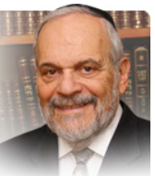

He certainly emerges from the entire bewildering and tragic events as a heroic and noble figure, still the beloved son of his father and the heir to the double portion birthright of the first-born. Yet, in terms of the long-range view of Jewish history, Yosef is not the vehicle of Jewish survival. His kingdom of the northern ten tribes of Israel is relatively short-lived and riddled with wicked kings and widespread idolatrous practice. The kingdom of Yosef is never restored and the remnants of the northern ten tribes are eventually absorbed into the kingdom and tribe of Judah.

Yosef’s triumph is seen in Jewish history as being legitimate but essentially temporary. It his brother Yehudah who emerges as the ultimate hero and guarantor of Jewish survival and as the true head of Yaakov’s family. The Jewish people are called upon his name and it is through his descendants that legitimate royalty comes to Israel. The future salvation of Israel and the messianic vision of full and complete redemption and a better world for all are assigned to the family and descendants of Yehudah. He is the ultimate victor in the debate between Yosef and himself that this week’s parsha highlights.

The obvious question that presents itself is why this should be. After all it is Yosef who is the righteous one, the one who resisted physical temptation and who persevered in his loyalty to the ideals of the patriarchs of Israel under the most trying and difficult of circumstances. Yehuda on the other hand can be superficially judged and found wanting in his behavior regarding Tamar and in his leadership role in the sale of his brother as a slave. So why, in historical terms, is he the hero and savior of Israel while Yosef is not?

Though G-d’s will, so to speak, in all of these matters remains hidden and inscrutable to us mere mortals, a glimmer of understanding can come to us from the words of Yaakov that will appear in next week’s parsha. Yaakov blesses Yehudah for his ability to rise from error and tragedy and continue forward. It is Yehudah’s resilience that marks his character and behavior. He redeems himself from the error of his treatment of Yosef by his unconditional and self-sacrificing defense of Binyamin. He admits his error in condemning Tamar and their children become the bearers of Jewish royalty. The secret of Jewish survival lies in Jewish renewal and resilience. It is the one national trait that outweighs all other factors in Jewish history. It certainly is the one most in demand in our current Jewish world today as well.

*Reprinted from the current website of rabbiwein.com*

**Thoughts that Count for Our Parsha**

*For how shall I go up to my father, and the youth is not with me?* (Gen. 44:34)

Every Jew must ask himself this same question: After 120 years, how will I be able to face my Father in heaven "and the youth is not with me" - if I have wasted my younger years on trivial and frivolous pursuits? This is also a question to be asked by every Jewish parent: How will I answer to G-d "and the youth is not with me" - if I have not met the Jewish educational needs of my children, and allowed them to become estranged due to ignorance? *(Der Torah Kval)*

*You shall tell my father of all my glory ("kevodi") in Egypt* (Gen. 45:13)

The literal meaning of "kavod" is heaviness, weight or gravity. In other words, Joseph was asking his brothers to tell their father Jacob that despite his being in the spiritually unclean land of Egypt, he had managed to remain strong and connected to G-d. *(Butzina D'nehora)*

*I will go down with you to Egypt; and I will also surely bring you up again* (Gen. 46:4)

The Jewish people can rest assured they will eventually go out of exile, as the time must ultimately come for G-d to be revealed in the world. The only way this revelation can happen is for the Jewish people to be redeemed and their true advantage revealed in the world. *(Beit HaLevi)*

*Reprinted from Parshat Mikeitz 5762/2001 edition of L’Chaim*

**Chinese Celebrity’s Conversion to Judaism – Part 2**

**By Yehudis Litvak**

**The Road to Conversion**

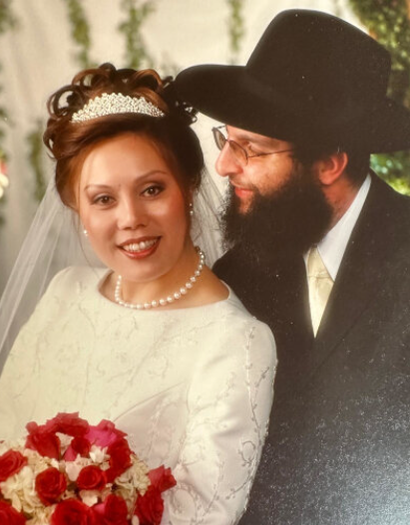

**Hong Zheng on her wedding day with Haim Tebeica**

At that point, Hong had never been to a synagogue and had not met religious Jews. Her decision to convert stemmed purely from her intellectual quest.

Hong’s friends, including some secular Jews, had tried to dissuade her. They told her that Judaism has too many restrictions and leads to a miserable life. But for Hong, it was a matter of principle. She wasn’t looking for an easy life. She was pursuing truth.

Hong’s first step was [keeping kosher](https://aish.com/48958906/). She didn’t know exactly what that entailed but she knew that religious Jews didn’t eat pork, so she decided to become a vegetarian. “If this is what it takes,” she said to herself, “I’ll see if I can do it.”

She recalls, “I lived in the downtown Flushing Chinese community, and there, the smells from Chinese cooking are all over. And I can’t deny that the food is delicious! It was not easy but I could do it! I asked myself if I would be able to do it for the rest of my life and decided that I could.”

Hong’s next step was keeping [Shabbat](https://aish.com/shabbat/). Just like with kosher, she did not know what that entailed, so did the safest thing – she stayed in her apartment the whole Shabbat and didn’t eat any hot food. After several weeks, she said to herself, “This is really hard! But can I do it for the rest of my life? Yes, I can.”

After reassuring herself that living an observant Jewish life was doable Hong decided that it was time to speak to a rabbi.

She’d never met a rabbi before and didn’t know where to find one. “I looked around,” she recalls. “There was a synagogue just across from the Chinese radio station. It was a beautiful large synagogue with a big Star of David and stained-glass windows. I walked in and said to the rabbi, ‘I would like to convert to Judaism.’

The rabbi said, ‘Wonderful!’ He received me very warmly, made a phone call, arranged for me to contact a school in Manhattan. But I just felt that something was off. I’d heard that Jews don’t really encourage you to convert. On the contrary, they might try to slow you down.”

On her way out, Hong asked the rabbi if he kept Shabbat and kosher. The rabbi told her that he drives to synagogue on Shabbat. “I politely said thank you,” says Hong, “but in my heart I turned that down. I had a good life in China that I could go back to any time. Why would I choose such a hard life if I wanted to do things superficially? What was the point?” She wanted to practice Judaism in the most authentic way.

**In Search for a Rabbi**

Hong was not sure where to turn to next. On the way to work, she noticed a building where people coming in and out looked visibly Jewish. She decided to go there.

When she walked in, she saw two teenage boys and asked them if she could speak to the rabbi. They went to check, then came back and told her that the rabbi wasn’t in. Hong asked for the rabbi’s phone number. They told her that the rabbi didn’t have a phone.

Hong thought to herself, *“Now I’ve come to the right place. They’re trying to push me off.”*

She told the boys that she would come at a different time and was about to leave when young adult men walked in and asked the boys what the visitor wanted.

Hong spoke up. “I’m interested in Judaism.”

The men laughed in her face. “It broke my heart,” Hong recalls. “I walked out with tears in my eyes. I was so embarrassed. I had gathered all my courage, came to a strange place, spoke in my broken English, and they just laughed at me.”

Hong says that today, she doesn’t blame the young men. She found out later that the building was a boys’ yeshiva, and the boys were not used to strangers walking in and inquiring about conversion.

But at the time, she began to doubt her decision to convert. Then she thought to herself, “What if this is a test? There is an easy way, but you don’t want them. And this is the real deal, and they don’t want you. Let me try one more time.”

Hong got into her reporter mode. She took a tape recorder, went to the main street of the Jewish neighborhood, and began interviewing Jewish women about their lifestyle.

One of the women spoke to her for some time and then asked Hong why she was asking all those questions. Hong admitted that she wanted to convert to Judaism but didn’t know how.

“Because of the interview, we built up some trust,” says Hong. The woman offered to help. She made some phone calls and put Hong in touch with Rabbi Meir Fund, who dealt with Orthodox conversions in Brooklyn.

Hong met with Rabbi Fund. “We spoke for over an hour,” she recalls. “After he heard what I had to say, he said, ‘Sounds like you’re very serious. Where do you live?’”

When Rabbi Fund heard that Hong lived in Queens, he recommended she meet Rabbi Peretz Steinberg. Rabbi Steinberg helped Hong with her conversion and continues to be her rabbi. He also suggested that Hong meet other conversion candidates.

Through him, Hong got in touch with an Italian American woman who was in the conversion process. They decided to meet at a synagogue in Queens.

When Hong walked into the synagogue, she heard the beautiful singing and burst into tears. This was her first time in an Orthodox synagogue and she finally felt that she’d come home. Until then, Hong’s conversion journey had been purely intellectual but now, her emotions got fully on board.

Hong threw herself into learning Hebrew and the basics of Judaism. As she learned the Torah with the traditional commentaries, she was even more impressed and moved by the text that had originally drew her to Judaism. She also felt that G-d was guiding her on her path. “My life is full of miracles,” she says.

For example, when she began keeping Shabbat, Hong lost two jobs, one after another. She was disappointed and unsure how she would make it in America all on her own, but she continued studying for conversion.

A few days after she converted, Hong got a job in a Jewish-owned Shabbat observant company, which paid better than her previous jobs had. Her boss even offered to give her a ride to work every day. She says, “G-d was telling me, ‘I know what you gave up. I’ll make it up to you.’”

Hong had also given up her whole TV career. She knew that once she became Jewish, she would no longer live in China where Jews were few and far between. A precondition for her conversion was moving into a Jewish neighborhood and joining a synagogue. She had decided that she would stay in America, improve her English, and get into a different line of work.

Staying in America was not so simple. China did not necessarily want to give up its prominent award-winning investigative journalist. Hong had to get a special permission from the Chinese government, which she eventually received thanks to her connections.

Because of her sincere commitment and dedication, Hong managed to complete her conversion within six months.

Upon converting, she chose the Hebrew name Esther Tiferes.

**The Jewish Dating World**

After her conversion, Esther began receiving invitations to speak at different synagogues. She is always happy to share her story.

At the same time, many well-meaning people began setting her up with Jewish men, but their attempts were not successful. Chinese converts don’t have an easy time in the Jewish dating scene.

Esther decided to approach dating just as she did everything else – directly and honestly. She posted her profile on a Jewish dating site and wrote, “I am a Chinese convert. If that bothers you, don’t waste your time.”

Esther’s future husband, Haim Tebeka, appreciated her directness. He contacted her, and the rest is history. They have now been married for over two decades and have three children.

**A Jewish Grandfather**

Decades after her conversion, Esther got a surprising glimpse of her family history. Growing up, she didn’t know much about her grandfathers. Both of them were unjustly accused and murdered by the communist regime. It was a stain on the family name, and no one ever spoke about them.

Recently, an old acquaintance mentioned to Esther’s father that his father, Esther’s paternal grandfather, had been Jewish. It was a shock to the whole family, but looking back, it made sense: Esther’s father is tall and has wavy hair, which is not the typical Chinese look.

Esther’s grandfather had been accused of spying for America because he worked as a general manager of an American bank and spoke four languages: Chinese, Japanese, English, and German. At the time, few people in China spoke German. Now Esther wonders if perhaps the fourth language was actually Yiddish.

The Chinese government did not keep any records, and all attempts to research Esther’s family’s history and learn more about her grandfather were futile. But it’s comforting for her to know that perhaps by practicing Judaism and raising Jewish children, she is continuing in her grandfather’s footsteps.

Today, Esther Tebeka lives in Las Vegas with her family and practices Chinese medicine – something she learned from her father, in addition to her conventional medical training. Her acupuncture clinic was rated top in Las Vegas. She finds fulfillment in helping people heal and live healthier lives and does not miss her TV career. Esther continues speaking at Jewish events, inspiring others with her story.

*Reprinted from the current website of aish.com*

**And Joseph gathered up all the money that was found...for the grain ("shever") that they bought ("shovrim") (Gen. 47:14)**

The Midrash relates that the coins of ancient Egypt bore the likeness of an idol. How, then, could Joseph have had anything to do with an object that was tainted by idolatry? The answer lies in an alternate interpretation of the word "shever," which can also mean "to break." Before giving the coins to Joseph the Egyptians broke them up in pieces, thereby nullifying their idolatrous quality. *(The Rabbi of Zidatchov)*

*Reprinted from Parshat Mikeitz 5762/2001 edition of L’Chaim*